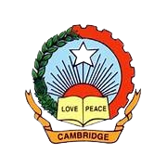
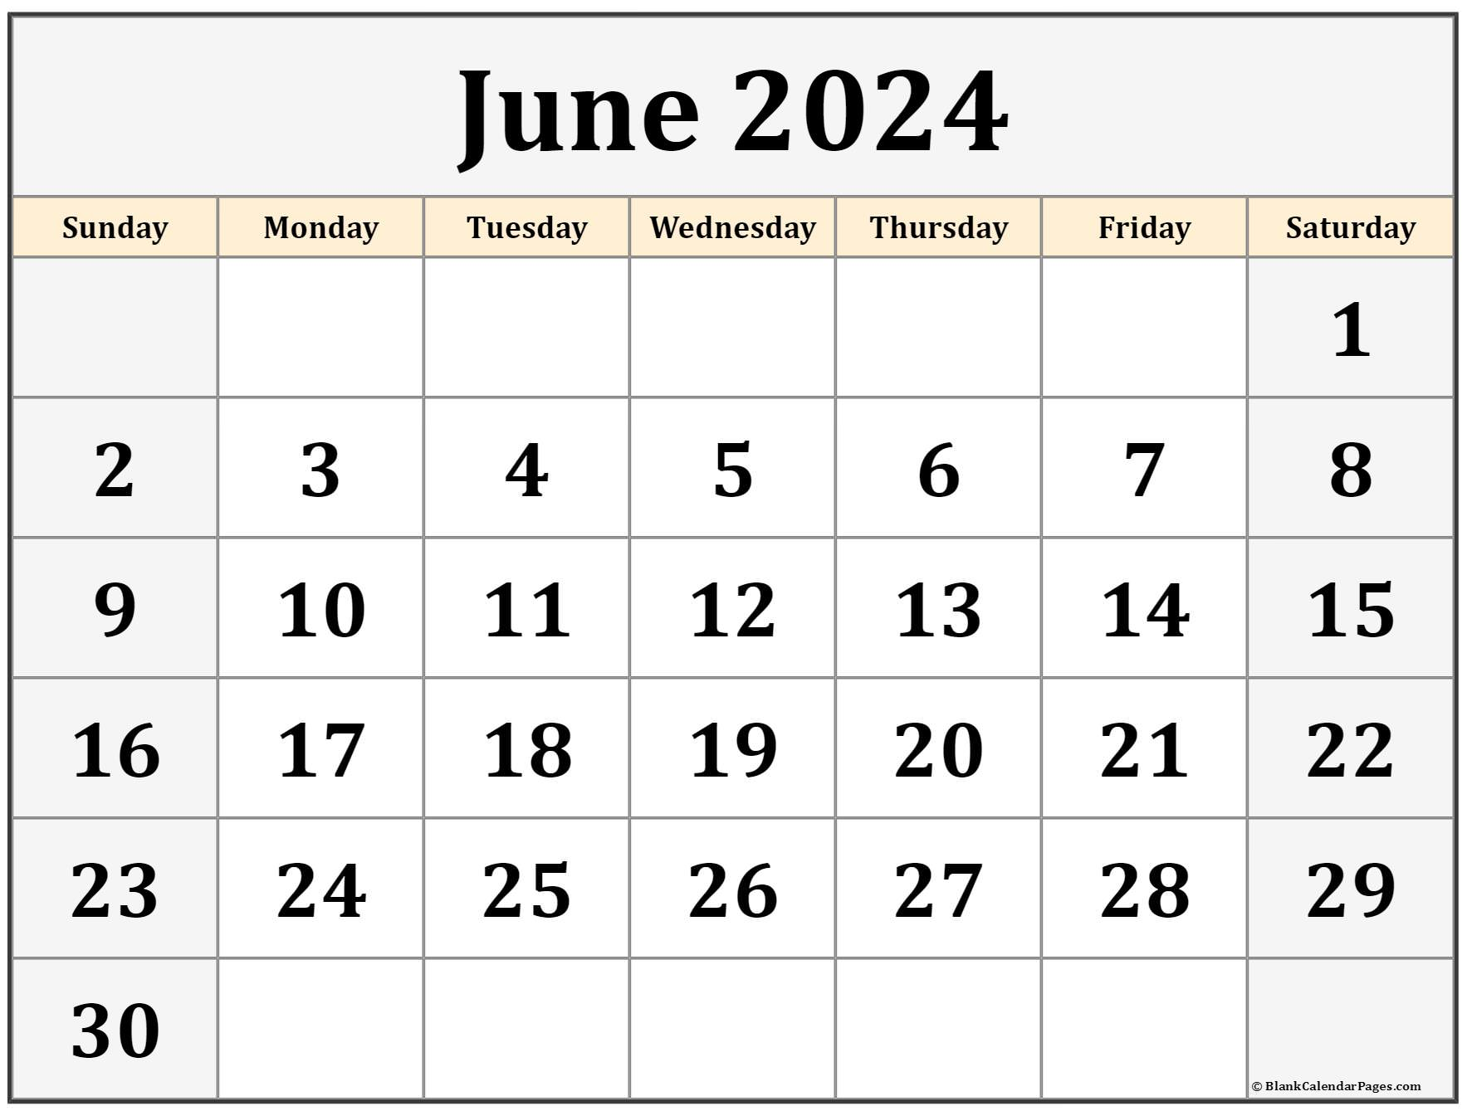
Competition Theme: BACK TO SCHOOL
---------------------------------Reading Week -----------------------------------------
Bakri-Eid Holiday
____------------------------------------------------------Back To School Activities------------------------------------------
Father’s Day Activities
Investiture Ceremony
World Yoga and Music Day
School Re-opens Nur
School Re-opens Jr&Sr.KG
School Re-opens I-VIII
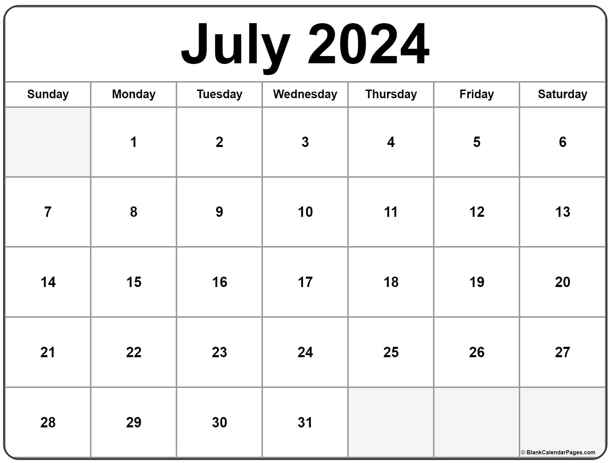
Moharram Holiday
Competition Theme: VERBATLLE
Tiger Day
Nature Conservation Day
KG_IV
Kargil Vijay Diwas
V-VIII
I Unit Test
I-VIII
Guru Purnima Activity
VII-VIII
Emoji Day
------------------------Monsoon Sports Festival----------
IV-VIII
Monsoon Celebration (Blue Day)
KG-II
------------------------------------------------------Doctor’s Day Activities--------------------------------------------------------------------------------------------------
Plastic Free Day
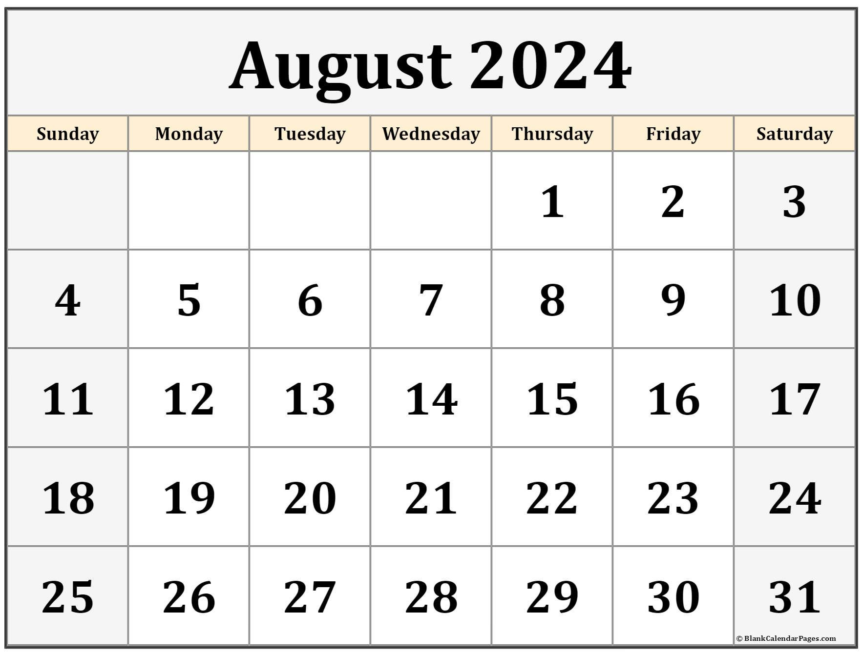
National Sports Day
World Photography Day
International Youth Day
Rakshabandan Activities
Friendship Day Activities
Cultural day (I-II)
Inter House Dance and Singing Competition (Patriotism)
Competition Theme: YOUNG PATRIOT
Competition Theme: VERBATLLE
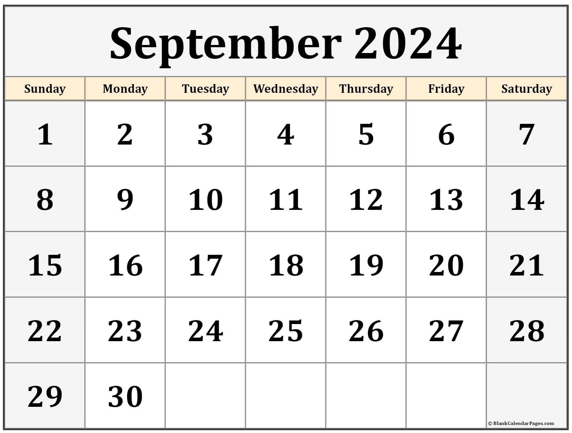
Tourism Day (Interhouse Competition)
Sign Language Day
Engineer’s Day Celebration
------------------------------------------------------------------------------------------------------------Hindi Week------------------------------------------------------------------------------------------
Eid-E-Milad Holiday
Teacher’s Day
I-VIII
Ganesh Chaturthi Holiday
II Unit Test
I-VIII
Competition Theme: HINDI VERBATTLE
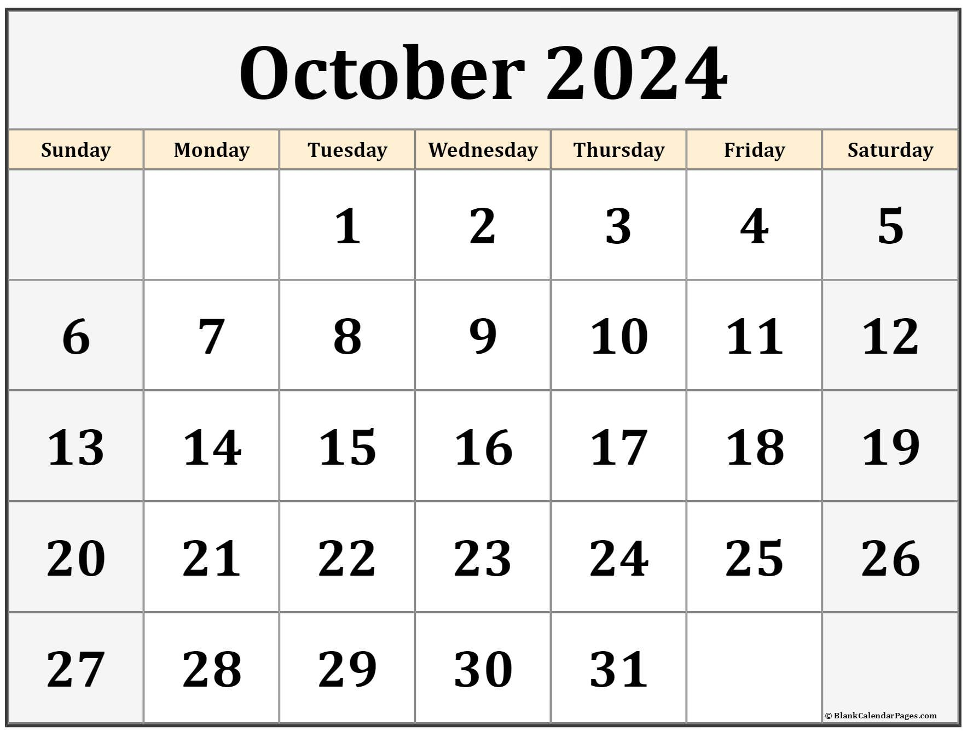
--------------------------------------------- Cambridge Got Talent---------------------------------------------------------
Diwali Vacation Begins
Dussehra
I SEM Exam Begins
Navratri Begins
Lal Bhadhur Shastri Jayanti and Gandhi Jayanti
Competition Theme: Talent Hunt
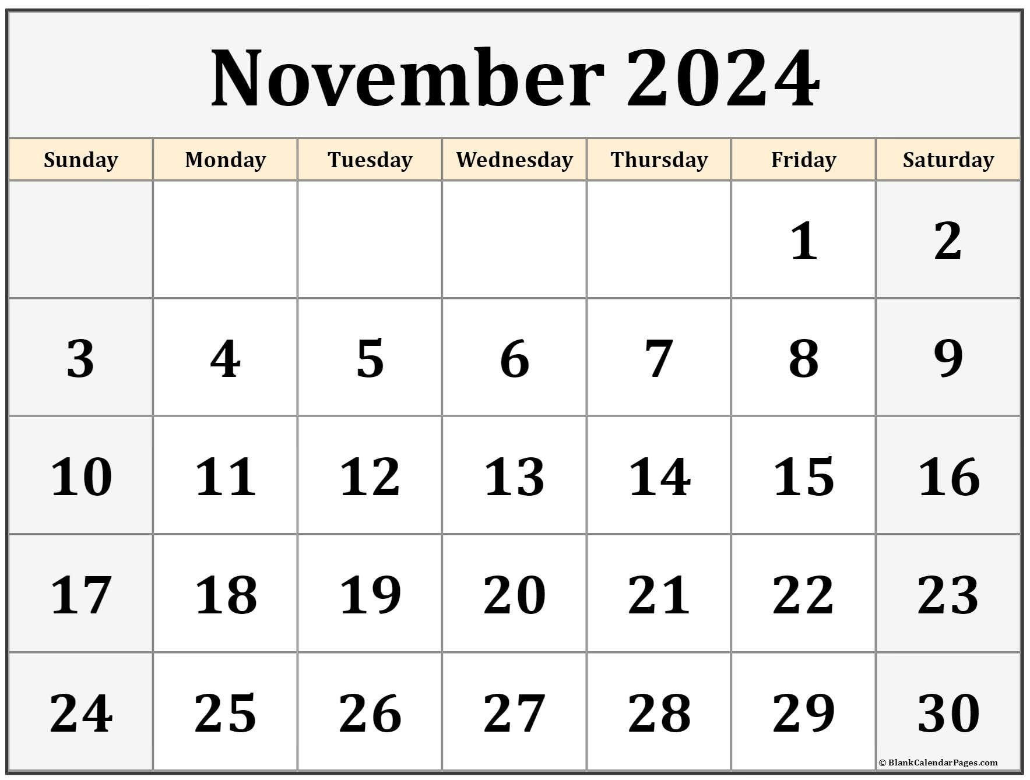
World Television Day
Guru Nanak Jayanti
Children’s Day
Competition Theme: Nutrition Awareness
School Re-opens
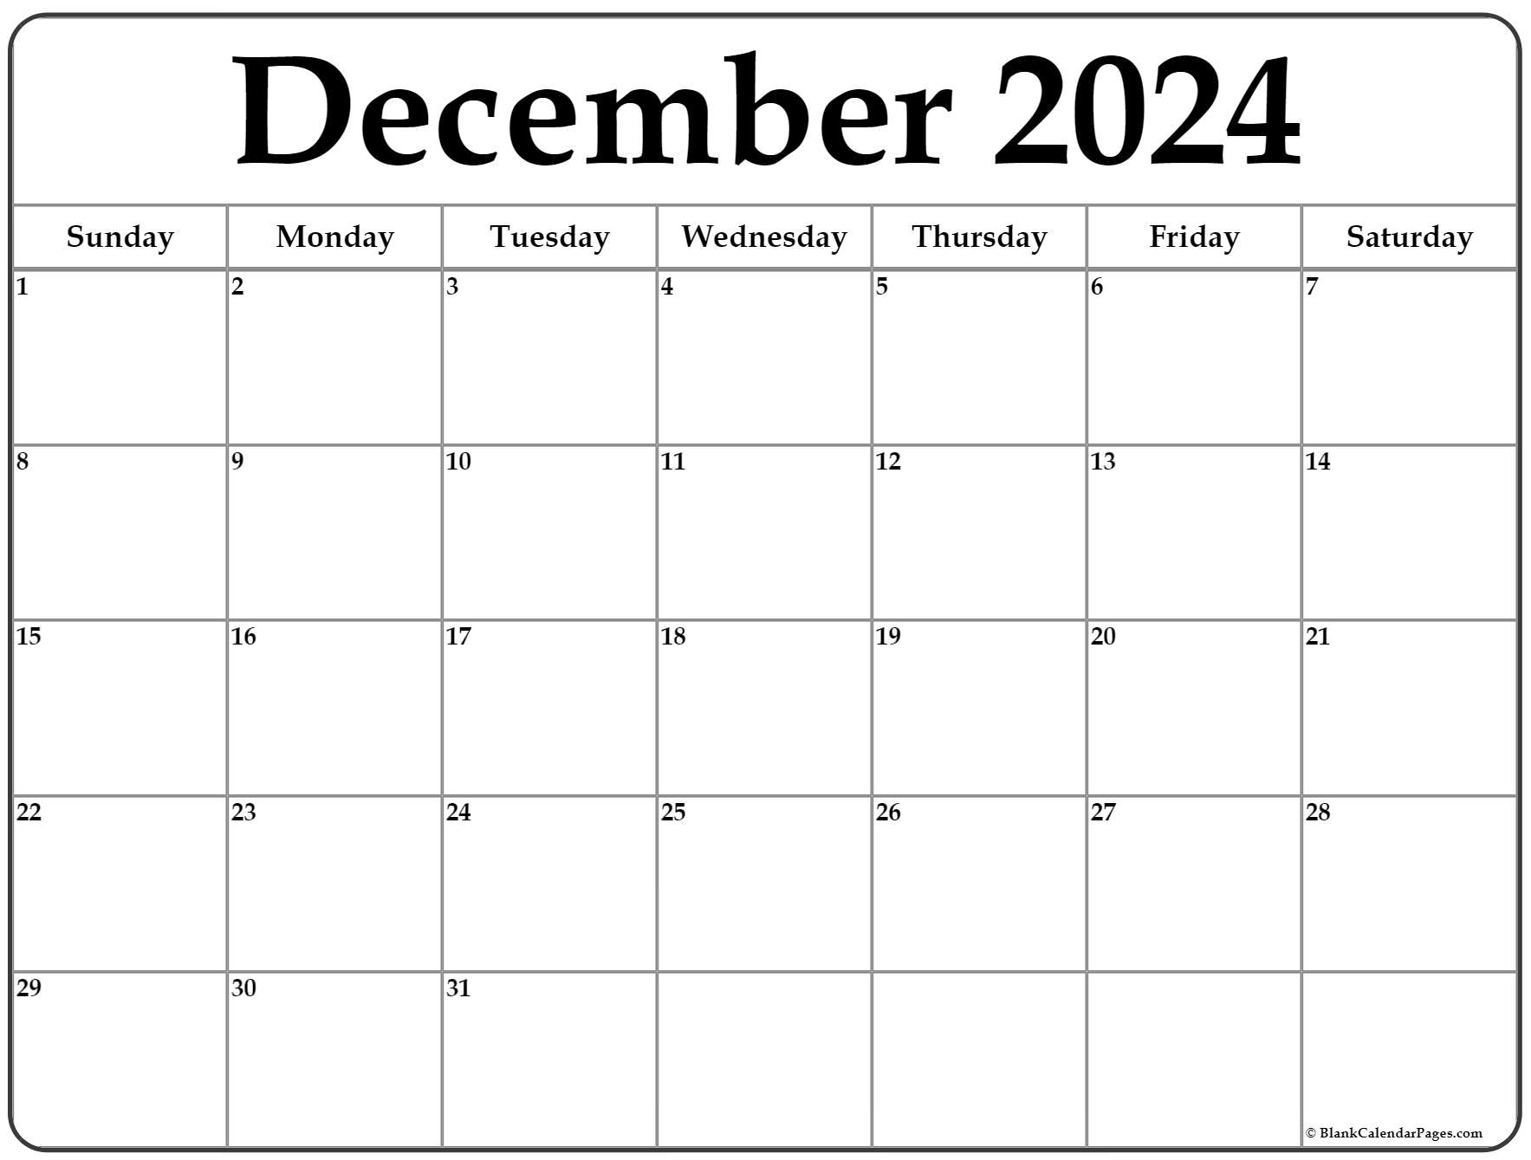
Sports Day
III Unit Test
I-VIII
Human Rights Day
Winter Vacation Begins
Navy Day
Competition Theme: Festivities
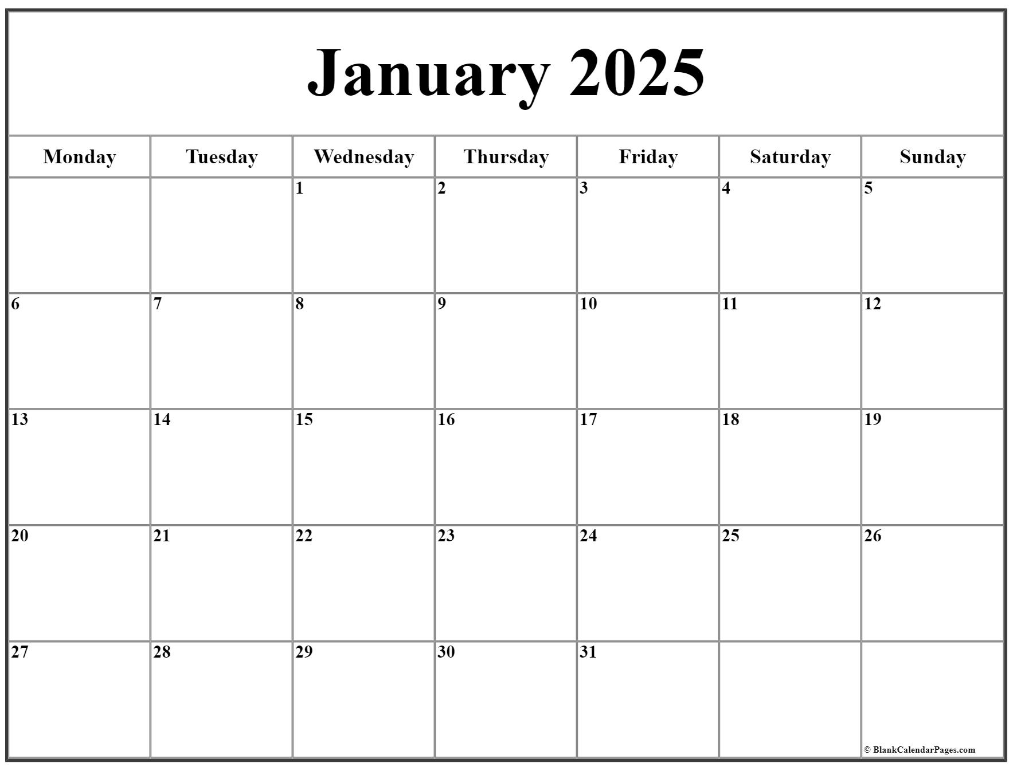
Annual Day
Indian Army Day
Makar Sankranti
School re-opens
Competition Theme: Resolutions
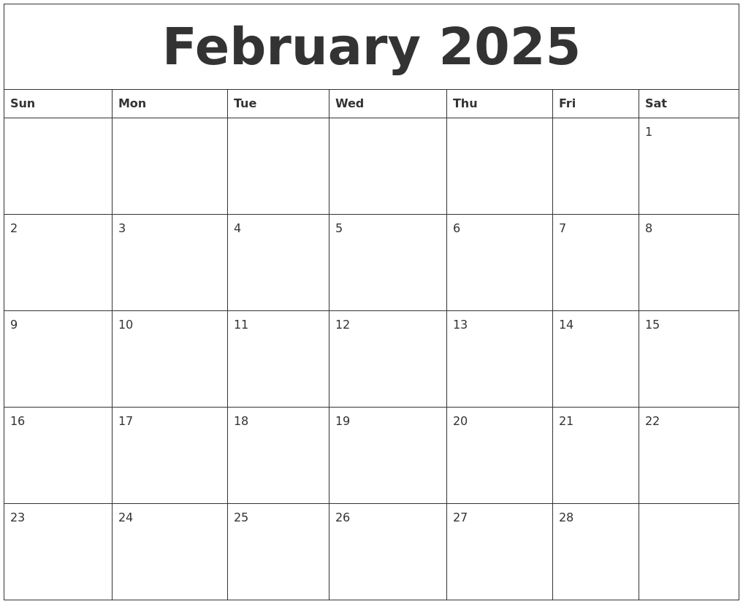
---------------------------------------------------------------------------- Literary Week-------------------------------------------------------------------
----------------------------------------------Science Week------------------------------------
Maha Shivratri
Chatrapati Shivaji Maharaj Jayanti
Competition Theme: Young Scientist
IV Unit Test Begins
I-VIII
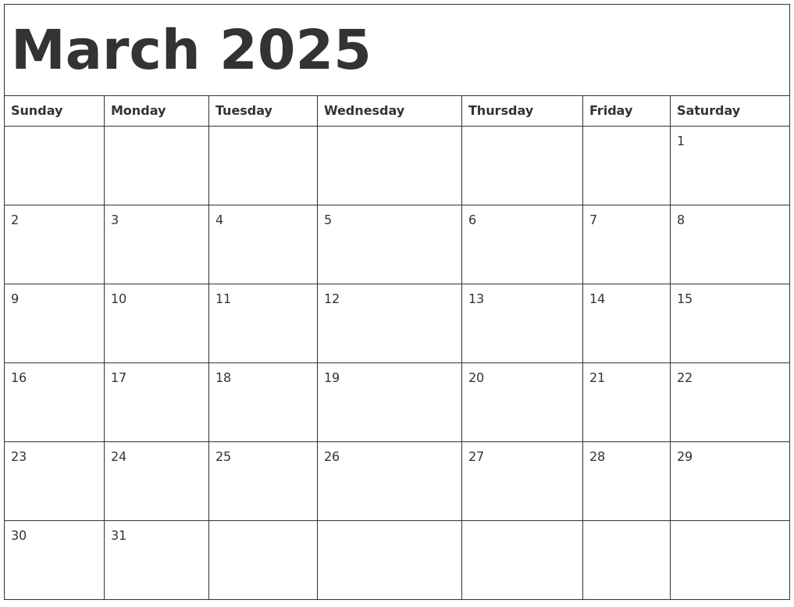
II Sem
KG-VII
Holi
Women’s Day
------------------------------------------------------------------------------------------------ Mathemagica-------------------------------------------
Competition Theme: Math Wiz
II Sem
VIII
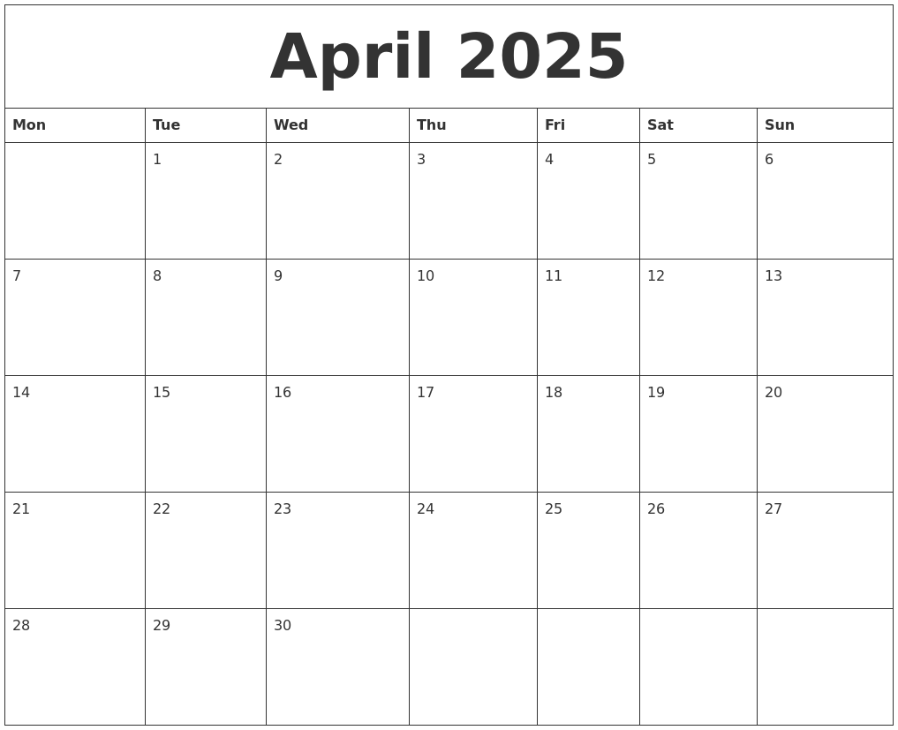
Competition Theme: Academic Excellence
